Software Requirements Specification
for
Project Stickman
Version 1.03 approved
Prepared by (Alex Pelnar, Nick Kuepper, Ryan Roemer, Chiang Lee)
Team 2
9-25-19
Table of Contents
Table of Contents ii
Revision History ii
1. Introduction 1
Purpose 1
1.1 1
1.2 References 1
2. Overall Description 1
User Classes and Characteristics 1
2.1 1
2.2 Operating Environment 1
Design and Implementation Constraints 1
2.3 1
2.4 Assumptions and Dependencies 2
3. External Interface Requirements 2
User Interfaces 2
3.1 2
3.2 Hardware Interfaces 2
3.3 Software Interfaces 3
3.4 Communications Interfaces 3
4. System Use Cases 4
4.1 Character Control (U1) 4
4.2 Enemy Control (U2) 5
4.3 Defeat Enemy (U3) 5
4.4 Save Game (U4) 6
4.5 Load Game (U5) 6
4.6 Pause Game (U6) 7
4.7 Create Level (U7) 7
4.8 Update Score (U8) 8
4.9 Win Game (U9) 8
4.10 End Game (U10) 8
4.11 Update Health (U11) 9
5. Other Nonfunctional Requirements 9
5.1 Performance Requirements 9
5.2 Safety Requirements 9
5.3 Security Requirements 10
5.4 Software Quality Attributes 10
6. Other Requirements 10
System Requirements Chart 10
7. 10
Appendix A: Analysis Models 11
Appendix B: To Be Determined List 12

Revision History
Name | Date | Reason For Changes | Version
Alex Pelnar | 9-25-19 | Start the document, create use cases. Name of the project is Project Stickman | 1.0
Alex Pelnar | 9-26-19 | Update use cases, create new use cases | 1.01
Alex Pelnar | 9-27-19 | Update use cases | 1.02
Alex Pelnar | 10-3-19 | Update use cases, add system requirements, add user classes and characteristics | 1.03
Alex Pelnar | 10-15-19 | Started Section 7 | 1.04
Alex Pelnar | 10-16-19 | Completed sections 2.3 and 2.4 | 1.05
Alex Pelnar | 10-17-19 | Started Section 5, continued Section 7 | 1.06
Alex Pelnar | 10-22-19 | Completed Section 5, Section 7 | 1.07

Introduction

Purpose

Project Stickman {version} is self-contained 2D platforming game where the player defeats enemies and competes against a time to gain points before reaching the end of the level. This document encapsulates the entirety of Project Stickman.

References

None

Overall Description

User Classes and Characteristics

- Player: Players will use the application to pass time and to entertain themselves. The technical experience of these users can be minimal, as only four keys on the keyboard are used for gameplay, and a tutorial is provided to instruct the user.
2.1.2 – Power User: Power users will use the application for testing purposes. These users will have the ability to choose which level to start at, and the ability to make their character invincible. The technical experience of these users will be substantially more than a Player, as these users will have access to the code base to make changes if the program is not behaving correctly. These users will also need experience in Unity and C#.

Operating Environment
Minimum Requirements: Windows 7 (Service Pack 1 or later), graphics card with DX10 (shader model 4.0) capabilities, and CPU with SSE2 instruction set support.

Design and Implementation Constraints

Unity version [whatever] is not installed on the machines on campus, which hinders working on the project during class hours, and working on the project simultaneously.

Due to the fact that each member of the team is using his own machine for the project, there is lack of a standard version between computers. Therefore, different versions of Unity are being used during development.

Likewise, due to a lack of standard for machine requirements between team members, the program may run slowly or have lag or glitches only on specific machines. This could cause issues during testing, as one member may see a bug that only exists on his machine, and is unfixable.

Not all members of the group had software capabilities to render graphics. Since this type of software is expensive, and there was no budget for this project, only one member was able to create graphics for the game.

Assumptions and Dependencies

- The team of developers is expected to be proficient in C# coding, as the project is written in C# code in Unity.

- Users are assumed to have a basic understanding of computers (how a mouse functions, how keyboards function) before starting the game.

- Users are assumed to be using a Windows operating system of Windows 7 or newer. The project is expected to run in iOS and Linux environments, but has not been tested on such machines.

External Interface Requirements

User Interfaces

Main Menu

<Screenshot w/ labels>

Pause Menu

<Screenshot w/ labels>

Level 1

<Screenshot w/ labels>

Additional Information:
- Project Stickman is not 508 Compliant
- The screen resolution used should be 1920 x 1080 or higher
- Aspect ratio of Project Stickman is 4:3
- The P button on the keyboard controls the pause functionality in the game
- -Font?
- -Button standards? Color, size, border style
- -Error message standards

Hardware Interfaces

Project Stickman requires a PC with a Windows operating system, 2GB of RAM, a keyboard, a mouse, and a hard drive of at least 1GB. Hard drives can be setup as IDE, SATA, or RAID.

Project Stickman uses the hard drive to save game data.

Software Interfaces

Project Stickman makes use of the Windows operating system and Unity libraries to run. Unity utilizes C, C++, and Objective C to run.

Project Stickman does not make use of any other outside software, nor is there any communication between Project Stickman and any other software.

Communications Interfaces

Project Stickman is a self-contained program; there are no external communication mechanisms.

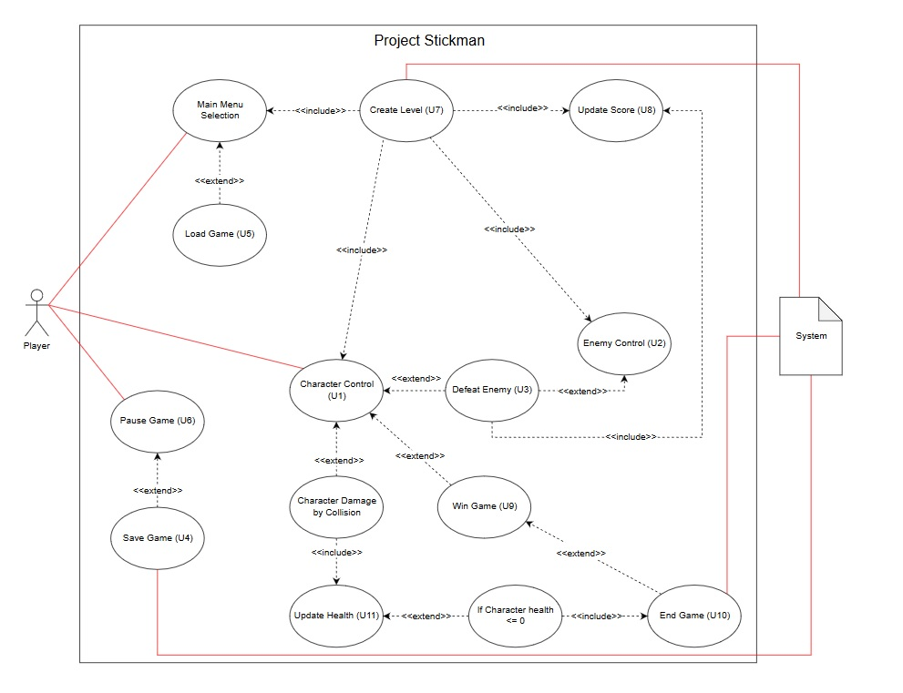
System Use Cases

Character Control (U1)
- Character Control (U1)
- Objective – The player is moving the character object in the Project Stickman to obtain points and reach the end of the level.
- Priority – High
- Source – Terry Shields (Project Manager)
- Actors – Player
- Flow of Events
  - Basic Flow
    - Player presses the left and right arrow keys.
    - System moves character sprite left and right accordingly.
    - Player presses the space bar to propel the character sprite upward.
    - System moves the character sprite upward.

    - Alternative Flow 1 – At any step the user presses the “P” key.
    - System executes Pause Game (U6).
  - Alternative Flow 2 – At any step the character sprite collides horizontally with an enemy sprite.
    - System executes Update Health (U11).
  - Alternative Flow 3 – At any step the character sprite collides with an obstacle.
    - System executes Update Health (U11).
  - Alternative Flow 4 – At any step the character collides vertically with an enemy sprite.
    - System executes Defeat Enemy (U3).
- Includes – Pause Game (U6), Update Health (U11), Defeat Enemy (U3)
- Preconditions – Player has started a new game or loaded a saved game.
- Post conditions – The character sprite changed positions on the screen.
- Notes/Issues – None

Enemy Control (U2)
- Enemy Control (U2)
- Objective –The system is moving enemy sprites towards the player to lower the player’s health.
- Priority – High
- Source – Terry Shields (Project Manager)
- Actors – Player, System
- Flow of Events
  - Basic Flow
    - Player moves character sprite in range of an enemy sprite.
    - System moves enemy sprite towards character sprite.

  - Alternative Flow 1 – At any step the character sprite moves out of range of the enemy sprite.
    - The enemy sprite moves in a random direction.
  - Exception Flow 1 – At any step the character sprite collides with enemy sprite horizontally.
    - System executes Update Health (U11)

  - Exception Flow 2 – At any step the enemy sprite collides vertically with enemy sprite.
    - System executes Defeat Enemy (U3).

  - Includes –
  - Defeat Enemy (U3), Update Health (U11).
- Preconditions – Player has started the game.
- Post conditions – The enemy sprite changed positions on the screen.
- Notes/Issues - None

Defeat Enemy (U3)
- Defeat Enemy (U3)
- Objective –The player defeats an enemy sprite by jumping on top of them.
- Priority – Medium
- Source – Terry Shields (Project Manager)
- Actors – Player, System
- Flow of Events
  - Basic Flow
    - Player moves character sprite in range of an enemy sprite.
    - Player presses left or right arrow keys and space bar to maneuver character sprite above enemy sprite.
    - Character sprite falls down vertically onto enemy sprite.
    - System compresses enemy sprite.
    - System removes enemy sprite from screen.
  - Alternative Flow 1 – At step 6.1.3, the player does not land on top of the enemy.
    - Go back to step 6.1.1.
- Preconditions – Player has started the game.
- Post conditions – The enemy sprite is removed from the screen.
- Notes/Issues - None

Save Game (U4)
- Save Game (U4)
- Objective –The player saves the instance of Project Stickman to be continued at a later time.
- Priority – Medium
- Source – Terry Shields (Project Manager)
- Actors – Player, System
- Flow of Events
  - Basic Flow
    - Player clicks the Save button.
    - System saves current health to save file.
    - System saves current time to save file.
    - System saves current character position to save file.
    - System saves current enemy positions to save file.
- Preconditions – Player has paused the game (U6).
- Post conditions – The player has saved this instance of the game.
- Notes/Issues - None

Load Game (U5)
- Load Game (U5)
- Objective –The player loads a saved instance of Project Stickman.
- Priority – Medium
- Source – Terry Shields (Project Manager)
- Actors – Player, System
- Flow of Events
  - Basic Flow
    - Player clicks the Load button.
    - System updates time from save file.
    - System updates health from save file.
    - System repositions character from save file.
    - System repositions enemies from save file.
    - Gameplay resumes.
- Post conditions – The player has loaded a saved instance of Project Stickman.
- Notes/Issues - None

Pause Game (U6)
- Pause Game (U6)
- Objective –The player pauses gameplay.
- Priority – Medium
- Source – Terry Shields (Project Manager)
- Actors – Player, System
- Flow of Events
  - Basic Flow
    - Player presses the “P” key on the keyboard.
    - System stops gameplay.
    - System displays Pause menu.
    - Player presses the “P” key on the keyboard.
    - System hides Pause menu.
    - System resumes gameplay.
  - Alternative Flow 1 – At 6.1.4, player clicks Restart.
    - System restarts level.
  - Alternative Flow 2 – At 6.1.4, player clicks Load.
    - System executes Load Game (U5)
  - Alternative Flow 3 – At 6.1.4, player clicks Resume.
    - System resumes gameplay.
  - Alternative Flow 4 – At 6.1.4, player clicks Save Game.
    - System executes Save Game (U4).
    - Continue at
  - Includes – Save Game (U4), Load Game (U5)
- Preconditions – Player has started the game.
- Post conditions – The player has paused gameplay.
- Notes/Issues – None

Create Level (U7)
- Create Level (U7)
- Objective – Game level is created
- Priority – Medium
- Source – Terry Shields (Project Manager)
- Actors – System
- Flow of Events
  - Basic Flow
    - System starts timer.
    - System displays score at 0.
    - System creates character sprite.
    - System positions character sprite.
    - System creates enemy sprites.
    - System positions enemy sprites.
    - System displays health at default.
- Preconditions – Player has started a new game.
- Post conditions – The level is created for the player to start.
- Notes/Issues – None

Update Score (U8)
- Update Score (U8)
- Objective –The system updates the score
- Priority – Medium
- Source – Terry Shields (Project Manager)
- Actors – Player, System
- Flow of Events
  - Basic Flow
    - Player defeats an enemy.
    - System adds points to total score.
    - System updates score text.
    - Player receives a power-up.
    - System adds points to total score.
    - System updates score text.
    - Player completes the level with more than 0 seconds left on the timer.
    - System adds points to total score.
    - System updates score text.
- Preconditions – Player has started gameplay.
- Post conditions – The system has updated the player’s score.
- Notes/Issues – None

Win Game (U9)
- Win Game (U9)
- Objective –The player completes the level.
- Priority – Medium
- Source – Terry Shields (Project Manager)
- Actors – Player, System
- Flow of Events
  - Basic Flow
    - Player moves character sprite towards end of level.
    - Player defeats characters to obtain points.
    - Player collects power-ups to obtain points.
    - Player reaches the flag signifying the end of the final level before timer reaches 0.
    - System updates the score.
    - System updates High Scores with score if it is a new high score.
  - Alternative Flow 1 – Player health reaches 0.
    - System executes U10.
- Preconditions – Player started gameplay.
- Post conditions – The player has won the game.
- Notes/Issues - None

End Game (U10)
- End Game (U10)
- Objective – Gameplay ends.
- Priority – Medium
- Source – Terry Shields (Project Manager)
- Actors – Player, System
- Flow of Events
  - Basic Flow
    - Player’s health reaches 0.
    - System updates health.
    - System stops timer.
    - System pauses gameplay.
    - System displays Game Over screen.
  - Alternative Flow 1 – At step 6.1.1, the timer reaches 0.
    - Go to step 6.1.3.
  - Includes –Pause Game (U7)
- Preconditions – Gameplay has started
- Post conditions – Gameplay is ended
- Notes/Issues - None

Update Health (U11)
- Update Health (U11)
- Objective –Updated player’s health
- Priority – Medium
- Source – Terry Shields (Project Manager)
- Actors – Player, System
- Flow of Events
  - Basic Flow
    - Character sprite collides horizontally with enemy sprite.
    - System subtracts from total health.
    - System updates health on screen.
    - Character sprite flickers.
    - Character sprite cannot take damage for 3 seconds.
  - Alternative Flow 1 – Player obtains a health pack.
    - System adds health to total health.
    - System updates health on screen.
- Preconditions – Gameplay has started.
- Post conditions – Player’s health is updated.
- Notes/Issues - None

Other Nonfunctional Requirements

Performance Requirements
See section 7 requirements SR12 through SR13.

Safety Requirements

See section 7 requirement SR14.

Security Requirements

There are no security requirements for this project. Project Stickman does not utilize any personal information, nor does it open any paths for data breaches.

Software Quality Attributes

See section 7 requirements SR15 to SR21.

Other Requirements

Copyright Disclaimer under section 107 of the Copyright Act of 1976, allowance is made for “fair use” for purposes such as criticism, comment, news reporting, teaching, scholarship, education and research.

Fair use is a use permitted by copyright statute that might otherwise be infringing.

This project does not directly make use of any copyrighted elements, but some of the general ideas (mystery boxes, flag at the end of the level, basic GUI screen) are based heavily on Nintendo’s Super Mario Brothers franchise.

System Requirements Chart

ID | Priority | Type | Source | Use Case | Description
SR1 | High | F | Terry Shields – Project Manager | U1 | The system must move the character sprite according to player control.
SR2 | High | F | Terry Shields – Project Manager | U2 | The system must move enemy sprites in direction of character sprite.
SR3 | Medium | F | Terry Shields – Project Manager | U3 | The system must remove enemies from play and add points to total points when an enemy is defeated.
SR4 | Medium | F | Terry Shields – Project Manager | U4 | The system must save the position of the character sprite, points, health, time, and position of enemy sprites.
SR5 | Medium | F | Terry Shields – Project Manager | U5 | The system must reposition the character sprite and enemy sprites, and updated the health, time, and points to match the saved file.
SR6 | Medium | F | Terry Shields – Project Manager | U6 | The system must stop gameplay when requested by player.
SR7 | Medium | F | Terry Shields – Project Manager | U7 | The system must create the level, including positioning the character sprite, enemy sprites, obstacles, and item boxes.
SR8 | Medium | F | Terry Shields – Project Manager | U8 | The system must keep track of the player’s score.
SR9 | Medium | F | Terry Shields – Project Manager | U9 | The system must end the game and provide a winner’s screen when the player completes each level.
SR10 | Medium | F | Terry Shields – Project Manager | U10 | The system must end the game when the player either completes each level, or their health reaches 0.
SR11 | Medium | N | Terry Shields – Project Manager | U11 | The system must keep track of the player’s health.
SR12 | High | N | Terry Shields – Project Manager | - | There cannot be any delay between pressing the keys on the keyboard and the movement on screen.
SR13 | Medium | N | Terry Shields – Project Manager | - | Saving or loading a game cannot take more than 3 seconds.
SR14 | High | N | Terry Shields – Project Manager | - | This system may cause seizures in individuals with epilepsy or who are sensitive to light. A warning will be included in the game to warn of this.
SR15 | Medium | N | Terry Shields – Project Manager | - | The project will need to be updated periodically due to changing versions of Unity and new technologies. Updates will be made every 6 months by 2 programmers.
SR16 | Medium | N | Terry Shields – Project Manager | - | System will have a low failure rate (<1 time every 50 uses).
SR17 | Low | N | Terry Shields – Project Manager | - | System will take <5 minutes to learn to use. Average time to complete Tutorial is 4 minutes.
SR18 | Medium | N | Terry Shields – Project Manager | - | System is able to run on Windows, iOS, and Linux with minimal testing. Changes made will take approximately a week with 2 programmers.
SR19 | Medium | N | Terry Shields – Project Manager | - | All scripts will be written in C#
SR20 | Medium | N | Terry Shields – Project Manager | - | The UI should be intuitive, easy to navigate
SR21 | High | N | Terry Shields – Project Manager | - | Script code will be easy to navigate, will be held to StyleCop standards.

Appendix A: Analysis Models
<Optionally, include any pertinent analysis models, such as data flow diagrams, class diagrams, state-transition diagrams, or entity-relationship diagrams.>

Don’t do any of these for CS421 SRS. You will create these models during the high level design deliverable.
Appendix B: To Be Determined List
<Collect a numbered list of the TBD (to be determined) references that remain in the SRS so they can be tracked to closure.>

List here any open questions or things you know still need to be done to the SRS, but haven’t been addressed yet. (It’s okay to have things like that, especially in this project because we don’t have time to do everything.)

